TOPICS

* Behavioural and structural UML diagrams (static and dynamic), their purpose and elements: use case, activity, state, sequence, class, component diagrams.
* Advantages of architecture document. Architectural templates: MVC, repository, layered, client-server.
* Component/module. What is component/module? What is difference between module and object?
* Cohesion and coupling. Levels of cohesion and coupling.

UML

* Difference between static and dynamic UML model.
* List any 3 UML diagrams that can be used to model the dynamic behavior of the system.
* List any 3 UML diagrams that can be used to model static system structure. Explain the purpose of the diagrams you listed.
* What does the generalization in the class diagram represent?

- What does the composition relation in the class diagram represent?

- What does the aggregation relation in the class diagram represent? Give examples. Which implementation does it fit programmatically?

Examine the UML diagram

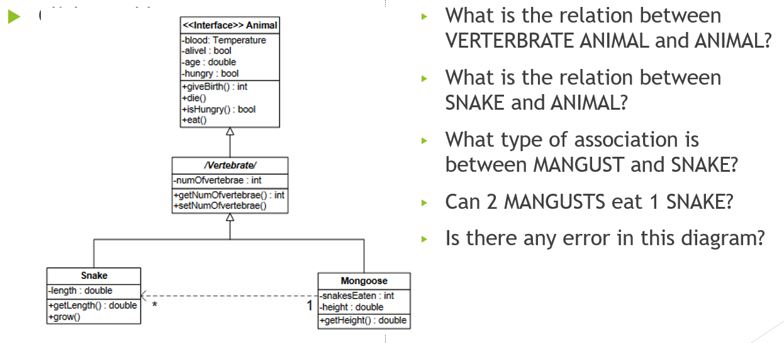

Examine the UML diagram. Simplify it

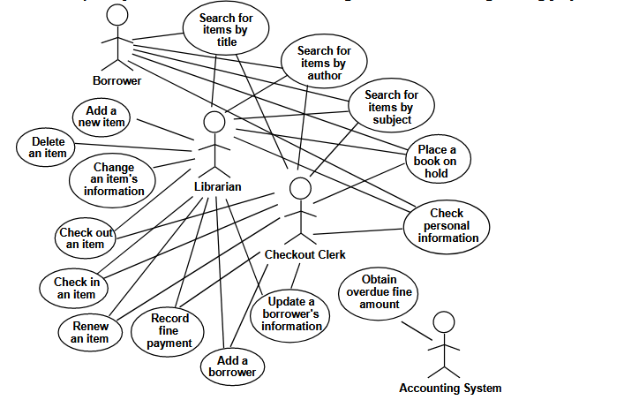

What UML diagram is this? What are the elements of the diagram?

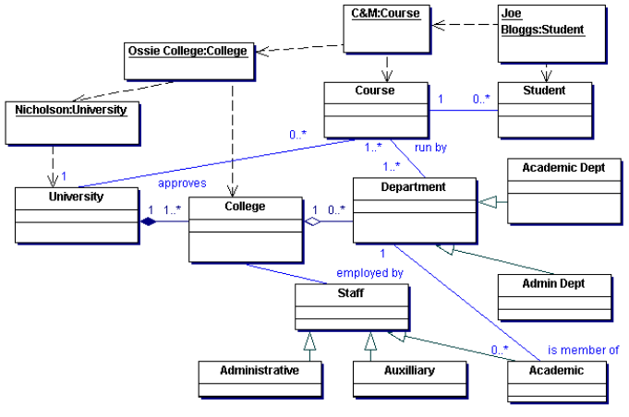

What diagram is given in the picture?   
What elements can you identify?

A close up of a map

Description generated with very high confidence

Architecture

* The company wants to convert a desktop application that uses a local database into a web application that will have access to the database on the server. Discuss the architecture of both systems and identify the steps required for conversion.
* What are Architecture Templates?
* What is the difference between closed and open layered architecture?
* What is MVC template? What are its advantages and disadvantages? What systems can be developed using this template? Give examples.

What architecture is shown in the picture?   
What are the benefits of this architecture?

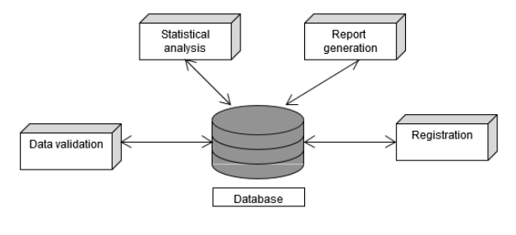

Module / component

* What is a module / component?
* How does a module / component differ from an object?

Coupling and cohesion

* What is coupling?
* What is cohesion?
* What is the best coupling between modules?
* What is the best cohesion of the module?